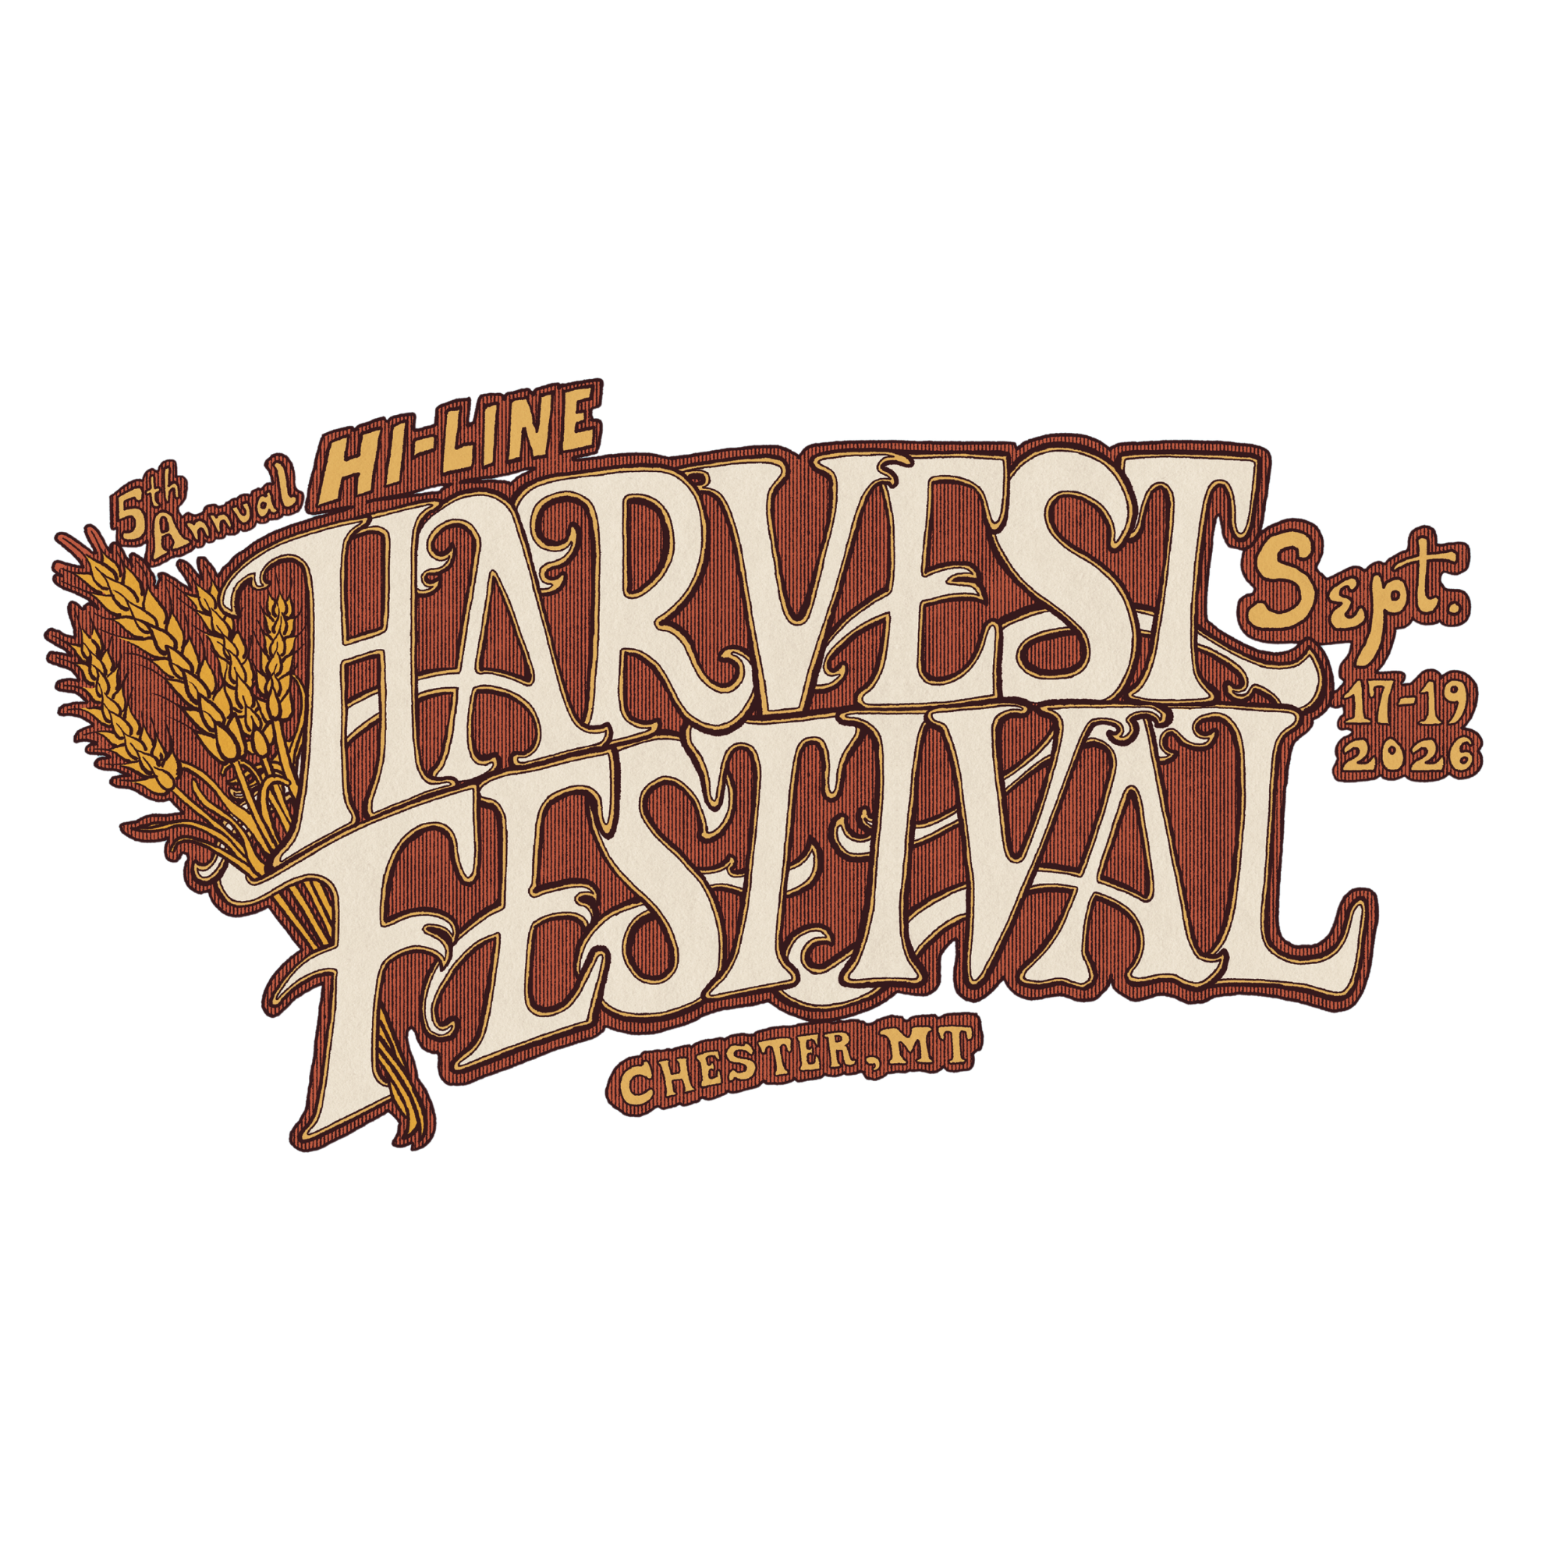
Hi-Line Harvest Festival

Small Business Grant

Grant Overview
The Hi-Line Harvest Festival is pleased to offer two (2) Small Business Growth Grants of $1,000 each to support local businesses in their growth, improvement, and long-term success.

Eligibility Requirements
Applicants must meet all of the following criteria:
- Operate a legally registered business & employ 15 employees or less.
- Be a current Liberty County Chamber member in good standing or commit to becoming a Chamber member and maintaining membership for a minimum of two (2) years.
- Submit a completed application by September 1st, 2026.

Use of Funds
Grant funds may be used for business-related expenses that contribute to growth, efficiency, marketing, equipment purchases, technology improvements, workforce development, or other approved business needs.
Funds must be used within one (1) year of receiving the grant. If funds were not used within one year of receipt, any excess funds must be returned to the Liberty County Community Development Committee.

Recipient Requirements
Grant recipients agree to:
- Utilize all grant funds within one (1) year of the award date: September 19th, 2026.
- Maintain documentation of all expenditures.
- Submit copies of receipts demonstrating how grant funds were spent.
- Provide photographs showing the project, equipment, improvements, or activities funded by the grant.
- Submit a brief written report to the Hi-Line Harvest Festival within one year describing:
  - How the funds were used
  - The impact on the business
  - Any measurable outcomes or successes resulting from the grant

Selection Criteria
Applications will be evaluated based on:
- Demonstrated business need
- Potential impact of the grant funds
- Commitment to business growth and community involvement
- Clarity and feasibility of the proposed use of funds

Award Information
Two grants of $1,000 each will be awarded at the 5th Annual Hi-Line Harvest Festival on Saturday, September 19th, 2026. The Hi-Line Harvest Festival reserves the right to verify eligibility, request additional information, and determine final award recipients at its sole discretion.
By accepting a grant award, recipients agree to fulfill all reporting and documentation requirements outlined above.

